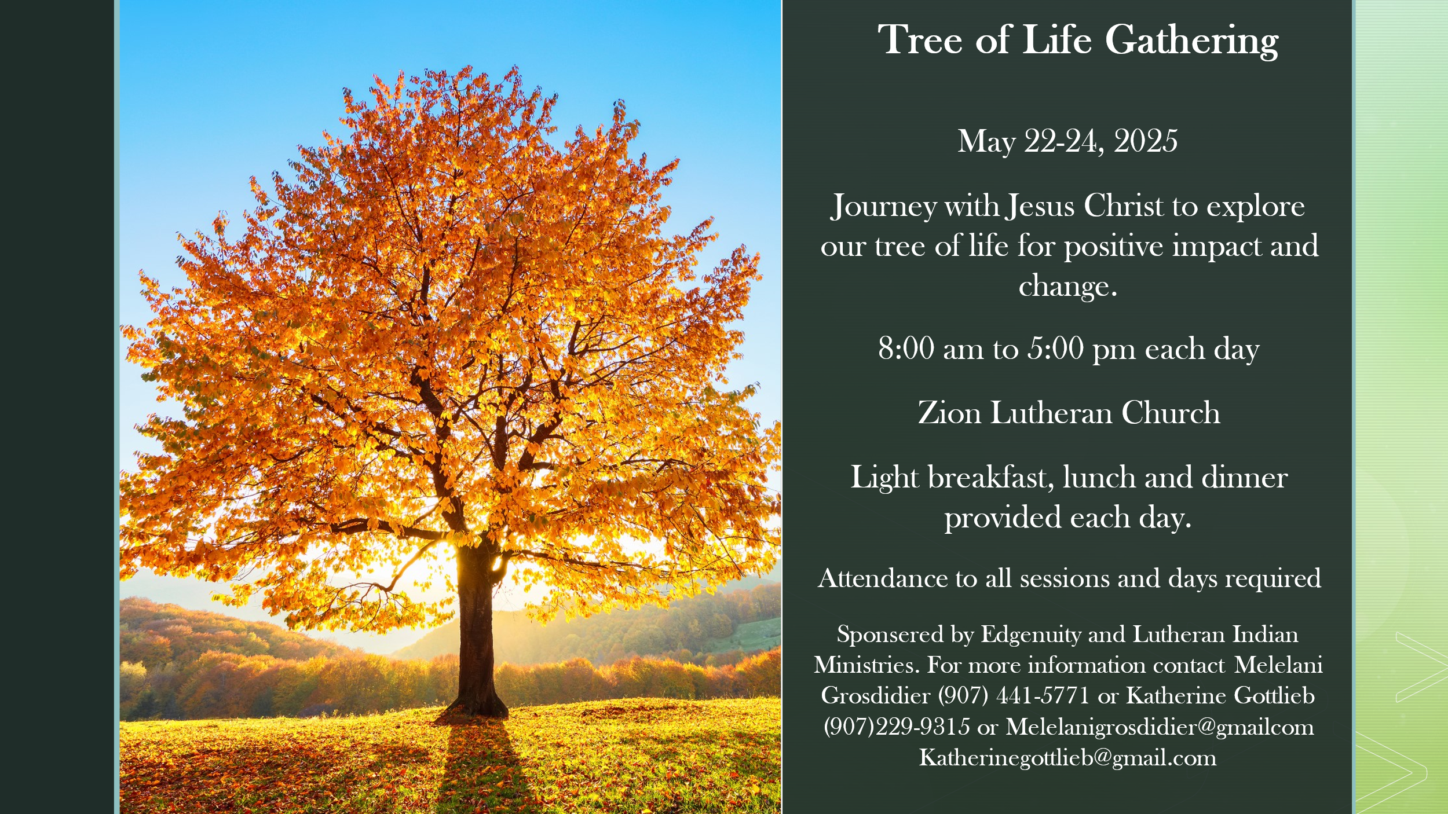

Tree of Life Gathering

Vision: God’s people standing in the light with one another
Mission: Journey with Jesus Christ to explore our tree of life for positive impact for change.

Through the sharing and telling of story participants will:

- Learn tools to share, listen and respond in a safe and open environment
- Explore ways to prevent harm from generation to generation
- Receive hope and healing from past trauma
- Be able to discover and share roots of personal life story
- Find hope and tools to heal from past harm

Tree of Life Application

All information provided in this application will be kept strictly confidential.

Name: ____________________________________________________________________________________

Address: ____________________________________________________________________________________

____________________________________________________________________________________

Phone: (cell)___________________________________ (alt #)___________________________________

Email: ____________________________________________________________________________________

Emergency Contact Name:______________________________________ Phone #:_________________________

Age Range (check one): __21 – 30 years __30 – 50 years __50+ years

Gender: __Male __Female

Race/Ethnicity (select all that apply):

__AK Native __American Indian __Caucasian __Black or African American

__Native Hawaiian __Pacific Islander __Hispanic __Other ____________________________________

What is your highest level of education? _________________________________________________________

If you require any special accommodation (mobility, schedules, etc.) please describe:
_________________________________________________________________________________________________

_________________________________________________________________________________________________

Are you able to attend the three full days of the gathering, including all small and large group sessions and the evening celebration activities on the last day? __Yes __No

If ‘No’ please explain:_____________________________________________________________________________

Briefly describe your experience, if any, with domestic violence and/or child abuse or child neglect:

_________________________________________________________________________________________________

_________________________________________________________________________________________________

Sometimes the effects of domestic violence, abuse and/or neglect can lead to other things that may need to be addressed prior to participating in the event. Do you struggle with any behavioral health disorders and/or addictions (drug, sexual, alcoholism, food, etc.)? If yes, please describe: _____________

_________________________________________________________________________________________________

_________________________________________________________________________________________________

If yes, are you currently receiving care for any of the above items? __Yes __No

Are you currently in a relationship where you do not feel safe? __Yes __No

If ‘Yes ’ please explain:_____________________________________________________________________________

Are you currently in a situation where you do not feel safe in your home? __Yes __No

If ‘Yes’ please explain: _____________________________________________________________________________

Are you experiencing an unusual amount of stress or significant transition in your life? __Yes __No

If ‘Yes’ please explain: _____________________________________________________________________________

Have you ever had serious thoughts of suicide or have made an attempt or a plan to in the past? _Yes _No

If yes, where are you today thoughts of suicide? _______________________________________________
___________________________________________________________________________________________

Have you received or witnessed trauma within the past 12 months? __Yes __No
If yes, please provide a brief description: _____________________________________________________

What does your support system consist of? (group support, counseling, partner, family, church, etc.):
_________________________________________________________________________________________________

I agree to: Attend each day and all sessions
Refrain from the use of drugs or alcohol
I will not share or disclose any personal information about other participants without their consent.

I acknowledge that I may be called as part of the application process and those that attend will be called within two weeks after as a part of the follow-up process:

Please be advised that while we respect your privacy, we are also mandated reporters. This means we are legally obligated to report any disclosures of harm to yourself or others, including abuse, neglect, or threats of harm to the appropriate authorities as required by law.

Photography permission:
O Yes, I do give permission to Edgenuity to use photographs, videos, or audio clips for outreach, advertising, and publications.

____________________________________________________ ________________________________
Signature Date

Participant Assumption of Risks, Indemnity Agreement
AND LIABILITY WAIVER AND RELEASE

I, the undersigned, acknowledge and agree to the following terms and conditions as a condition of my participation in Tree of Life Gathering. I understand that my participation in this conference is voluntary and that I may withdraw at any time. I acknowledge that the content may involve emotional, mental, and spiritual content as part of the healing process, which may be challenging or difficult for participants. I certify that I have sufficient skill and fitness to participate in the activities offered in the Tree of Life Gathering
I understand that my participation may involve certain inherent risks, including but not limited to emotional distress, physical discomfort, or other personal reactions as I engage in the conference activities. I assume all risks associated with my participation, including any effects that may arise during or after the event.
In consideration of being permitted to participate in the Tree of Life Gathering, I hereby release, waive, discharge, and covenant not to sue Edgenuity and Tree of Life Gathering, its creators, teachers, facilitators, affiliates, employees, volunteers, and the owners of the venue/building, from any and all liability for any injuries, illness, damages, claims, or demands that I, my heirs, or any personal representatives may have arising out of or in connection with my participation in this conference. This waiver includes but is not limited to any claims for physical or emotional injury, negligence, or any other liability.
I acknowledge that I am solely responsible for my own health and well-being and that I am not under the influence of any substances that would impair my ability to participate in the event activities safely. I agree to notify the organizers immediately if I experience any health issues during the conference.
I agree to indemnify and hold harmless Edgenuity, Tree of Life Gathering, its creators, teachers, facilitators, affiliates, employees, volunteers, and venue/building ([Venue Name]) from any claims, liabilities, damages, or expenses arising from my actions or conduct during the conference.
This waiver and release shall be governed by and construed in accordance with the laws of the state of Alaska.

As lawful consideration for being allowed to participate in activities offered in the Tree of Life Gathering, I expressly agree and promise to accept and assume all the risks existing in these activities. My participation in this activity is purely voluntary, and I elect to participate in spite of the risks. I expressly agree and acknowledge that the terms and conditions of this Assumption of Risks, Release of Liability, and Indemnity Agreement are contractual in nature and that I am signing it of my own free will.

By signing below, I confirm that I have read, understood, and agree to the terms and conditions of this Liability Waiver and Release Form.

Participant Signature: _______________________________________________

Date: ____________________________________________________________

